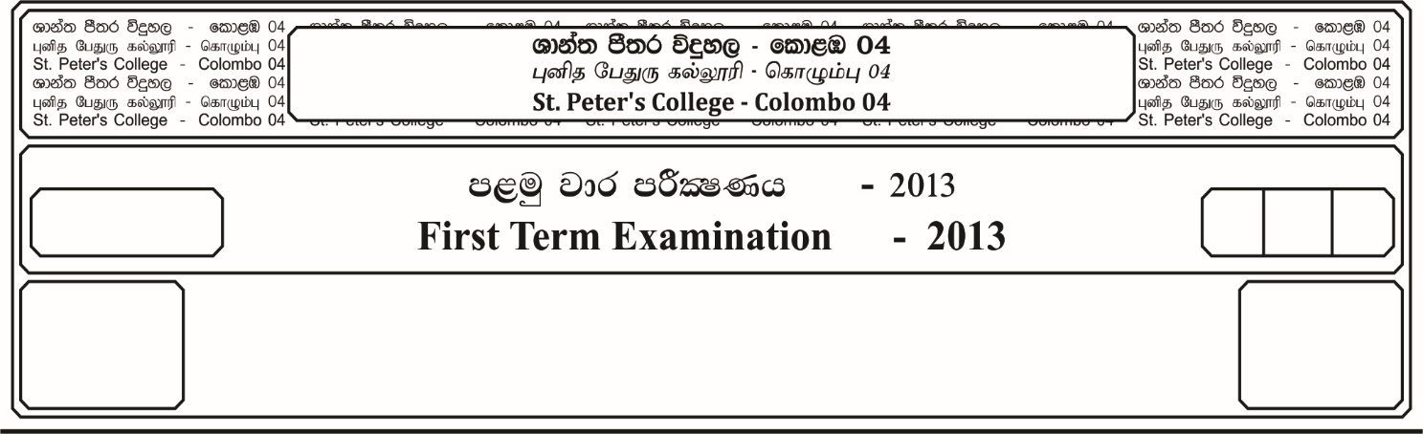

**fojk jk jdr mÍCIKh - 2023**

**Second Term Examination - 2023**

ixhqla; .Ks;h - ¸¸

**COMBINED MATHEMATICS – II**

II

E

10

$03$ meh

$03$ Hour

13 fY%aKsh

GRADE 13

* **Answer all the questions of Part A and any 05 questions of Part B.**

**Part -A**

01. A heavy ball drops from a celling of a room and after rebounding twice from the floor reaches a height equal to the one half of the ceiling. Show that the coefficient of restitution of the ball is .

02. The position vectors of the points $A$, $B$ and $C$ with respect to the origin $O$ are

$\underline{a} = 3\underline{i}+ \underline{j} , \underline{b}= \underline{i} -2\underline{j}$ and $\underline{c} = 3 \underline{i}-2 \underline{j}$

Show that vector $\vec{oc}$ is perpendicular to

03. One end of a light inextensible string which passes over

2mg

B

3mg

A

a smooth fixed pulley ***A***, carries a particle of mass ***3m***.

The string passes under a smooth pulley ***B***, which carries

a particle of mass ***2m***. The other end of the string is attached

to a ceiling as shown in the figure. The system moves

freely under gravity. Show that the tension in the string is

04. Let ***R*** be the horizontal range and ***H*** be the greatest height of a projection. If ***U*** is the intial velocity of the projection, then show that,

05. The resultant of two unequal forces ***P*** and ***Q*** is $\sqrt{3} Q$ and makes an angle $30°$ with the direction of **P**. Prove that

06. ***P*** and ***Q*** are two ports on the same coast of a river which flows uniformly. ***A*** steam boat takes $t_{1}$ seconds to move from $P$ to $Q$ and $t_{2} (>t_{1})$ seconds, to move from **Q** to **P**. Show that the time taken by a log of wood to floot freely from **P** to **Q** is .

07. Three forces ${\underline{F} }_{1}= \underline{i} +2\underline{j}$, ${\underline{F} }_{2}= -2i+P\underline{j}$ and ${\underline{F} }_{3}=q\underline{i}-3\underline{j}$ act on a particle. If the particle is in equilibrium, find the values of ***P*** and ***q***.

08. A uniform ladder rests with one end on a horizontal floor and the other end against a vertical wall, the coefficient of friction being respectively $\frac{3}{7}$ and $\frac{1}{3}$. Find the inclination of ladder when it is about to slip.

09. A particle ***P*** of mass ***2m***, hanging freely from a horizontal

Q

P

ceiling by a light inextendible string of length **l,** is in

equilibrium. Another particle ***Q*** of mass ***m*** moving in

a horizontal directionwith velocity ***V*** collides with the

particle ***P*** and coalesces to it. The string remains taut

after the collision and the composite particle just reaches

the ceiling. Show that V = $3\sqrt{2gl}$.

60 $°$

60

A

C

B

W

10. The given figure represents ***a*** framework of three light

rods AB, BC and AC, smoothly jointed at the ends.

It carries a load W at B and it is kept in equilibrium

with AC hosizontal, by two light vertical strings

connected to A and C. Draw a stress diagram,

using Bow’s notation find the stresses in all the rods

determine whether they are tensions or thrusts.

**Part – B**

11. a). An object ***A*** is dropped freely from a vertical post of height ***h*** and afters a time ***T*** another object ***B*** is projectsed down from the same point with a velocity $U (>gT)$. Draw velocity time graphs for the motion of both objects on the same set of anes and hence,

i. Show that the time taken for the two objects to collide is $\frac{T}{2}$ $\left(\frac{2u-gT}{u-gT}\right)$

ii. Show also that,

$\sqrt{\frac{2h}{ g }}$**- T > $\frac{{gT}^{2}}{2 (u-gT)}$** ( $g$– gravitational acceleration)

b). Ship $P$ which is travelling of $4u kmh^{-1}$ due North observe another ship $Q$ which seems to be travelling with a velocity of $2\sqrt{3} U {kmh}^{-1}$ in the direction, at an angle $60°$ East of south. Find the speed and the direction of **Q**. If **Q** does not change its course of direction then find the direction in which **P** should travel in order to meet **Q** and show that they meet after a time,

hours.

12. a). A wedge of mass $M$ with an inclination $∝$ to the horizontal is placed on a smooth horizontal surface. Two masses ***m*** and ***2m*** are attached to the ends of a light inextensible string and placed on the face of the inclined plane of the wedge passing over a light pulley fixed at the highest point of the wedge. When the system is released from rest show that, the acceleration of the wedge is,

$\frac{mgSin∝. Cos ∝}{3M+m (8+ {Sin}^{2}zx)}$

Find also the accelerations of two masses relative to the wedge.

b). A car whose mass is ***Mkg***, runs freely down a slope of ***l*** in ***P*** with a constant speed, show that, when it travels up incline ***l*** in ***q*** with a constant speed ***V***. The power developed is ***Mgv $\left(\frac{1}{P} + \frac{1}{q}\right)$***  watt, where the speed in both cases are the same.

13. a). A particle $P$ of mass $m$ is attached to a light inextensible string $OP$ of length a can rotate in a circle, centre $O$ with the string taut. If $U$ is the horizontal velocity of $P$ at the lowest point. When $OP$ makes an angle $θ$ with the downward vertical the tension ***15*** the string is ***T*** and the velocity of the particle is ***V***, then show that,

$V^{2}= U^{2}-2ag+2ag cos θ$

and

$T=$ $\frac{m}{a}$**($U^{2}-2ag+3ag cos θ$)**

i. If $U^{2}<2ag$ then show that the particle describe an are of a circle.

ii. When the speed of the particle is $\frac{U}{2}$ then show that the inclination of the string is $2{Sin}^{-1}$ $\left[\frac{U}{4} \sqrt{\frac{3}{ag}} \right]$ with the downward vertical.

b). One end of an elastic string modulus of elasticity is ***mg*** and natural length ***a*** is fixed to a point on a smooth horizontal table and the other end is tied to a particle of mass ***m***, which lying on a smooth table. The particle is pulled to a distance where the extension of the string is ***b*** and then let go. Show that the time of complete oscillation is,

14. a). is the origin and the position vectors of the points $A$, $B$ and $C$ are

$\vec{OA}$**= $\underline{i}$ + $\underline{j}$, $\vec{OB}$ = $3\underline{i} + 4\underline{j}$**  and $\vec{OC}$ **= $x\underline{i}-2\underline{j}$** . By using vector method, Find,

i. $x$ so that **A**, **B** and **C** are collinear

ii. $x$ so that the points $A, B, C$ form a triangle right-angles at $B$

b). Forces $3P, 7P, P, 2P mP$ and $nP$ act along the sides $\vec{AB}, \vec{ BC, } \vec{CD} \vec{DE} \vec{FE}$ and $\vec{FA}$ of a regular hexagon. Find the values of ***m*** and ***n*** if,

i. The six forced reduce to a couple.

ii. the system reduces to a single force along ***AD***.

W

$$∝$$

$$∝$$

W

B

D

F

E

W

W

C

A

15. a). Four equal uniform rods of length ***2a*** and each of

weight ***W*** freely jointed to form a rhombus ***ABCD***.

The rhombus is suspended from joint. ***A***, and is

maintained by means of a light rod ***EF*** joining

the middle points of ***BC*** and ***CD***, as shown is in

equilibrium ***B $\hat{A}$ D = 2 $∝$***. Find,

i. The stress in light rod ***EF***.

ii. The reactions at the joints ***C*** and ***D***.

$$45°$$

B

400 N

E

D

C

800 N

A

b). The diagram shows a framework is

made up of light rods, attached to a

vertical wall at ***A*** and ***E***, with ***AB***

and ***CDE*** are horizontal.

Assuming that the reaction at ***E*** is

along ***DE***. Find the reaction at ***A***.

Draw a stress diagram using Bow’s

notation and hence, find the stress in

the rods ***AB, BC*** and ***BD*** and state

whether they are tensions or thrusts.

16. a). Show that the distance of the centre of mass of a uniform circular solid cone from the vertex is $\frac{3h}{4}$, where h is the height of the cane.

A uniform solid paper weight is in the shape of a frustum of a cone. It is formed by removing a right circular cone of heights ***h*** from a right circular cone of height ***2h*** and base radius ***2r***. Show that the centre of mass of the paper weight lies at a height $\frac{11h}{28}$ from its base.

17. Define the angle of friction.

A uniform ladder of length **l** rests on a rough horizontal ground with its upper end project slightly over a smooth horizontal rail at a height ***a***. If the ladder is about to slip and $μ$ is the angle of friction on the ground. Show that,

$tan λ$**= $\frac{a \sqrt{l^{2}- a^{2}}}{l^{2}+ a^{2}}$**